Placement Providers
Information Pack
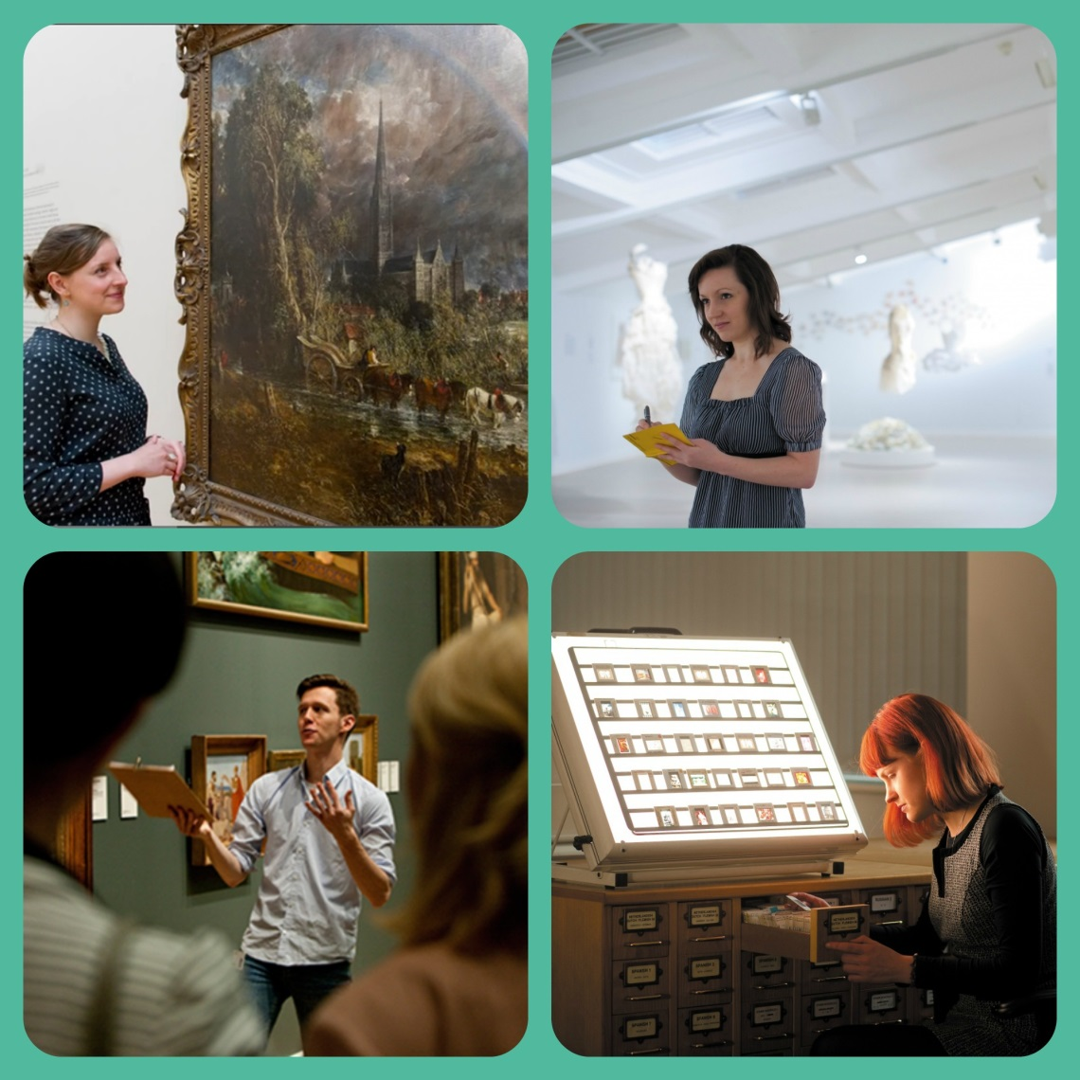

School of Humanities

Overview
The School of Humanities at the University of Nottingham is committed to enhancing graduate employability and have incorporated a new module for second year students to start in 2016/2017. This will give students the opportunity to gain hands on experience in a work based environment. The History of Art Department has already successfully included a pilot scheme connected to 5 work based local Arts organisations in the East Midlands. Three of our departments including Archaeology, Classics and Philosophy have joined the History of Art department in developing a new Placement module for 2nd year students to start in September 2016. The first Semester would incorporate delivering the relevant employability skills including CV writing and job applications. The Second Semester, February/March 2017, the individual students would then go onto a placement which would give them relevant insight into work based environments.
The Humanities school have developed their Employer Partnerships in the region so that students have a better insight into the sort of transferrable skills they can apply and also give them a clearer idea of the sort of career they wish to pursue after graduation.
We have therefore established a structured Placement Programme and Employer Partnerships for our students.
The Placement Programme enables students to enhance their employability by demonstrating and developing valuable skillsets which can be gained during their study in the department. Many of these skills are highly regarded by prospective employer organisations across a wide range of sectors.
The Humanities Placement Module include:
- 8 weeks – 7 hours per week local term time February/March, with the working pattern dictated by the placement provider.

- Accredited Placements – Tied to an accredited Student works with the provider whilst meeting the targets of their module at the same time!

The Opportunity…
You can benefit from a placement in your organisation in the following ways…
- Gaining a committed 2nd year Undergraduate to assist your organisation. Do you need a specific time-dependent project or report created? Are you looking for more day to day support such as a Communications or Media Officer, Researcher or a Data Analyst?
- No cost: The only cost to you as an organisation in most cases is in the time you spend inducting and supporting the Student whilst they are with you.
- Enhancing your organisation’s reputation within Nottinghamshire and the surrounding community, plus the opportunity to work with a World Top 100 University, part of the prestigious Russell Group.
- A golden opportunity to build up contacts and networks within the University environment.
- All our Students who apply for the Placement Module through a work based process including, CV, Statement of Interest and interview process, so you are in full control to select the best.
- All Student Placements undergo pre-placement training and have on-placement mentor support from the University. We also support you as the placement provider!

The organisation, although the project may be seen as a small part of operations, must:
- Treat recruitment and selection professionally.
- Ensure a good induction into the team, the organisation’s policies and principles, the project.
- Have a clear idea of the project aims and objectives before the start of the Placement.
- Provide appropriate levels of support for the placement holder throughout the project to ensure project success and that the outcomes are used to better the organisation.
- Have an allocated Mentor who can also liaise with the University Mentor and provide feedback to the University mid-way through the placement via email and by a short written report on the student’s contribution and development by the end of the placement.
Skillsets and competencies that Humanities Department Students provide Skills:
- Communications
- PR, Marketing and Branding
- Curating
- Research skills and research design
- Quantitative and qualitative data analysis
- Collecting, evaluating and collating data
“Arts graduates are able to take in complex information, process it quickly, and articulate the merits. This is vital for any organisation.”
Geoff Baker
CEO, ICN (Specialist App publisher)
- Presentation skills
- Debating and negotiation
- Ethics – Critical Thinking
- Public Engagement
- Networking
- Designing and conducting surveys
- Market research
- Field Reports
- Statistical analysis
- Editing and copywriting
- Critical and evaluative thinking
- Transcribing data to digitalisation
- Reading messages through texts
- Metaphysics – the fabric/nature of things
- Project Management
- Development and Event Organisation

Knowledge Areas:
- Archaeological sites/Companies
- Ancient History
- Archival work
- Charities
- Historical Languages
- History of Art
- Social and Global Justice
- Library Services
- Local government
- Museums and Galleries
- Refugee and Immigration Forum
- Schools – Delivery of project based subjects
- Social Philosophy – race/justice/gender
- Politics of race
- Gender politics

Interested? Next steps…
If you are interested in offering or developing placements in any of the above areas, please contact Helen Stevenson at Helen.Stevenson@nottingham.ac.uk at 0115 9515862 (Mon – Thurs 9.15 – 5.15) for more information and to discuss your ideas.

Process summary
- We take a role brief from you; confirm start dates, location, duration, hours and any desirable/essential criteria.
- We advertise the role internally with a closing date and provisional interview dates and using a structured application form.
- Interviews. You chose how many to shortlist. We also offer interview room facilities at the university free of charge.
- Placement offers are made by yourself to successful candidates and a contract signed and risk assessment undertaken.
- Preplacement training and support takes place with the student applicant before they start.
- The appropriate documentation will be sent to you and all relevant parties to ensure clear objectives and policy are in place.

Timelines
There will be some natural restrictions (exams and holidays) of when Placees can work on placement, but these are negotiated at the start of the process.
- Autumn Term: Mid-September to Mid-December – in-house training

- Spring Term: February to March student placement active in

Organisation

Examinations: students will not be able to commit to placements during their exam times. These vary but tend to be mid-January and mid-May to mid June
https://www.nottingham.ac.uk/humanities/index.aspx

