Placement Providers
Information Pack

School of Politics & International Relations – University of Nottingham

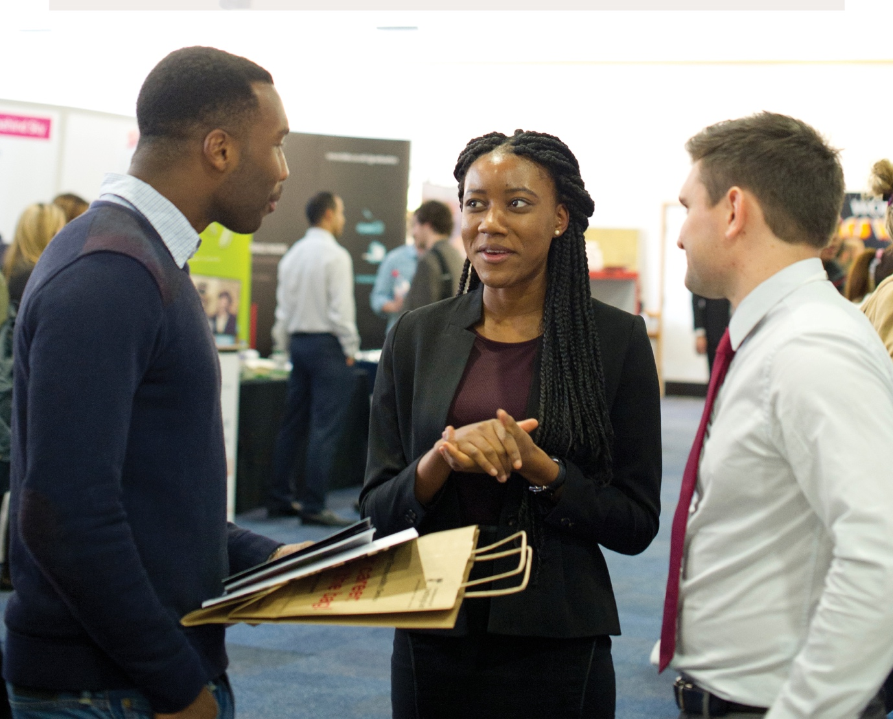

Overview
The School of Politics & International Relations at the University of Nottingham is committed to enhancing graduate employability. Recent research has shown that work experience is now just as important to employer organisations as is degree course and classification. We have therefore established a structured Placement Programme and Employer Partnerships for our students.
The Placement Programme enables students to enhance their employability by demonstrating and developing valuable skillsets (summarised below) gained during their study in the department. Many of these skills are highly regarded by prospective employer organisations across a wide range of sectors.
Voluntary Placement models include:
- 8 hours per week local term time placements usually running 8-12 weeks, with the working pattern dictated by the placement provider.
- Summer and Easter Placements (Local) – full time and part time. Usually running between 6-8 weeks for Summer and 2-4 weeks for Easter.
- Summer Placements (Nationally) – full and part time. Usually running for 6-8 weeks.
- Accredited Placements – Tied to an accredited module or Nottingham Advantage Award. Here the Placee works with the provider and towards their module at the same time!

The Opportunity…
You can benefit from a placement in your organisation in the following ways…
- Gaining a committed Politics Undergraduate or Masters Student to assist your organisation. Do you need a specific time-dependent project or report created? Are you looking for more day to day support such as a Communications or Media Officer, Researcher or a Data Analyst?
- No cost: The only cost to you as an organisation in most cases is in the time you spend inducting and supporting the Placee whilst they are with you.
- Enhancing your organisation’s reputation within Nottinghamshire and the surrounding community, plus the opportunity to work with a World Top 100 University, part of the prestigious Russell Group.
- A golden opportunity to build up contacts and networks within the University environment.
- All our Placees apply to placements through a competitive process, so you are in full control to select the best.
- All Placees undergo pre-placement training and have on-placement mentor support from the University. We also support you as the placement provider!

Faith Blakemore Events and Special Programmes Development Officer - Film Nottingham Office “…thank you for providing me with Alex Trimble as a placement...I am indebted to him, and you, for all his efforts which has given me great confidence in the placements scheme that the University of Nottingham provides, giving me assurance that I can work with you in the future to provide support and development for further placement individuals.”

Peter Saunders - Nottingham City Council “I’m impressed with the service you are providing both the students and potential clients to place students in a working environment that adds value to their career development and offers development opportunities, in our case, in the Transport Strategy team at Nottingham City Council.”

“The process has been very smooth, seamless and efficient and it’s encouraging and important that your role also includes pastoral supervision, mediation and brokerage for the placed students and a point of call for the City Council.”

Employer Organisations we work with
- Governmental organisations
- Non-Governmental organisations
- Local government or Local Council sponsored/funded organisations
- Charities and Third Sector organisations
- Lobbying and advocacy groups
- Communications and media
- Political Parties
- Public Services
- PLUS ANY local commercial businesses/SMEs that are looking to utilise any of the skills listed below ….

Skillsets and competencies that Politics & IR Students provide
Skills:
- Communications
- Marketing
- Research skills and research design
- Quantitative and qualitative data analysis
- Collecting, evaluating and collating data
- Presentation skills
- Debating and negotiation
- Networking
- Designing and conducting surveys
- Market research
- Statistical analysis
- Editing and copywriting
- Critical and evaluative thinking

Knowledge Areas:
- Law
- Languages
- Social policy
- Social and Global Justice
- Immigration policy
- Parliament
- UK politics
- Local government
- NGO
- Environmental policy
- Climate change
- Politics of race
- Gender politics
- International relations
- European Union
- Political Economy

Recent School of Politics and IR Placees:

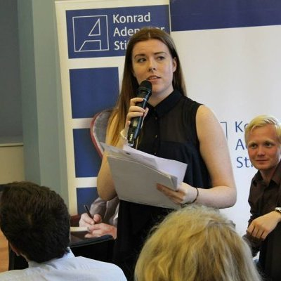

Interested? Next steps…
If you are interested in offering or developing placements in any of the above areas, please contact Steve Vaccarini at Stephen.Vaccarini@nottingham.ac.uk 0115 846 8161 or 07976 974204 for more information and to discuss your ideas.
I will be able to take job role briefs, and also support you in setting up the placements role from scratch.

Process summary
- We take a role brief from you, plus provisional start dates, location, duration, hours and any desirable/essential criteria.
- We advertise the role internally with a closing date and provisional interview dates and using a structured application form.
- Interviews. You chose how many to shortlist. We also offer interview room facilities at the university free of charge.
- Placement offers are made by yourself to successful candidates and a contract signed and risk assessment undertaken.
- Preplacement training and support takes place with the Placee before they start

Timelines
There will be some natural restrictions (exams and holidays) of when Placees can work on placement, but these are negotiated at the start of the process.
- Autumn Term: Mid-September to Mid-December
- Spring Term: Mid/late January to Mid-March
- Summer Term: Mid-April to mid-May
- Summer Period: Mid-June to Mid-September
- Examinations: students will not be able to commit to placements during their exam times. These vary but tend to be mid January and mid May-mid June

